SQL Exercise — Evidence of Execution
PostgreSQL 16, run locally via Docker — query text and live result grids for all 5 questions

Question 1 — Top 5 Products by Revenue
Top 5 products by total revenue from completed orders.
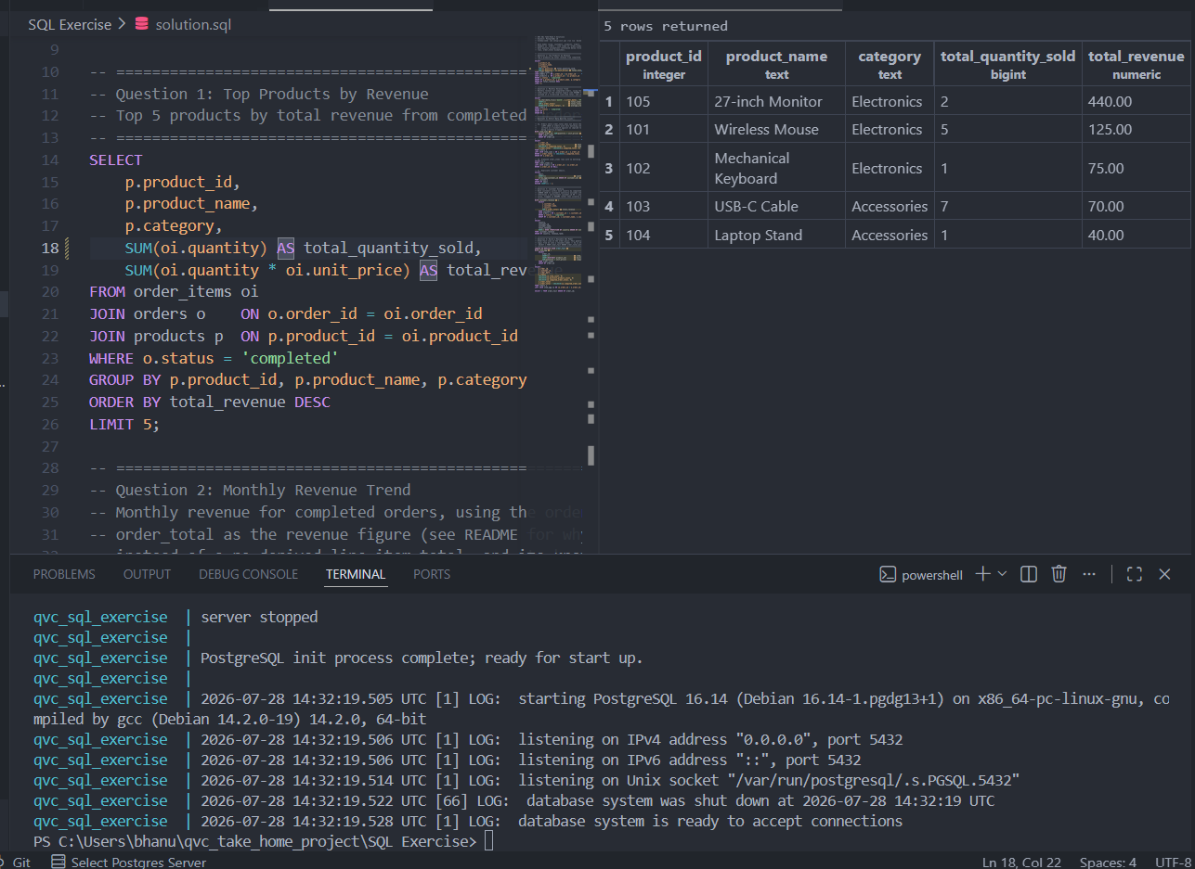

Question 2 — Monthly Revenue Trend
Monthly order count, revenue and average order value for completed orders.
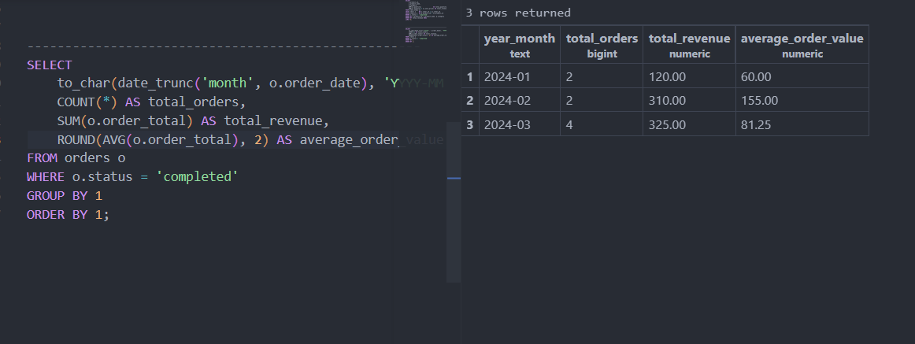

Question 3 — Data Quality Issues
Three distinct issues surfaced by inspecting the corrected data (see README → Data quality issues identified).

3a. Order-total mismatches
Recorded order_total vs. computed line-item total. Orders 1001 (95 vs 120) and 1005 (80 vs 85) disagree; order 1009 has zero matching order_items.
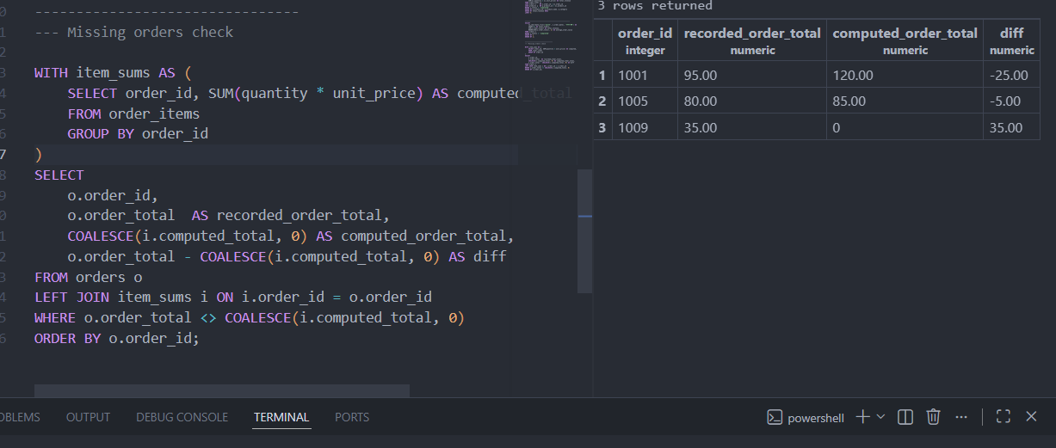

3b. Orphaned order_items
order_item_id 14 references order_id 9999, which does not exist in orders.
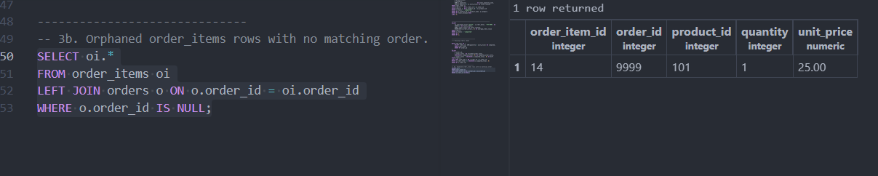

3c. Duplicate customer emails
alice@example.com is shared by customer_id 1 (Alice Johnson) and customer_id 8 (Hannah Scott).
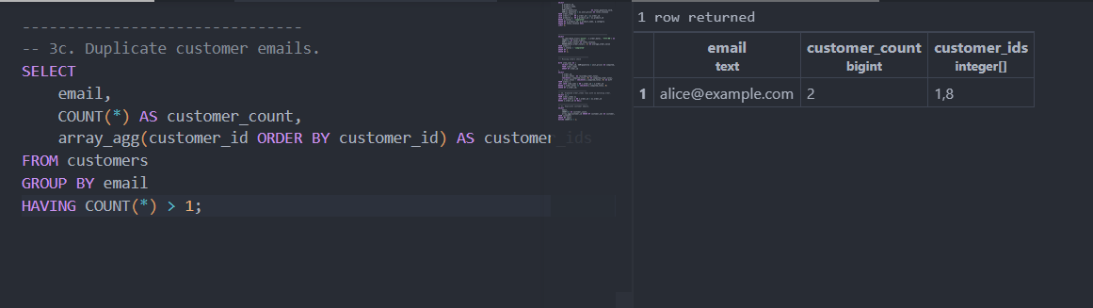

Question 4 — Customer Ranking by Revenue per Country
Customers ranked by total revenue within each country (window function, completed orders only).
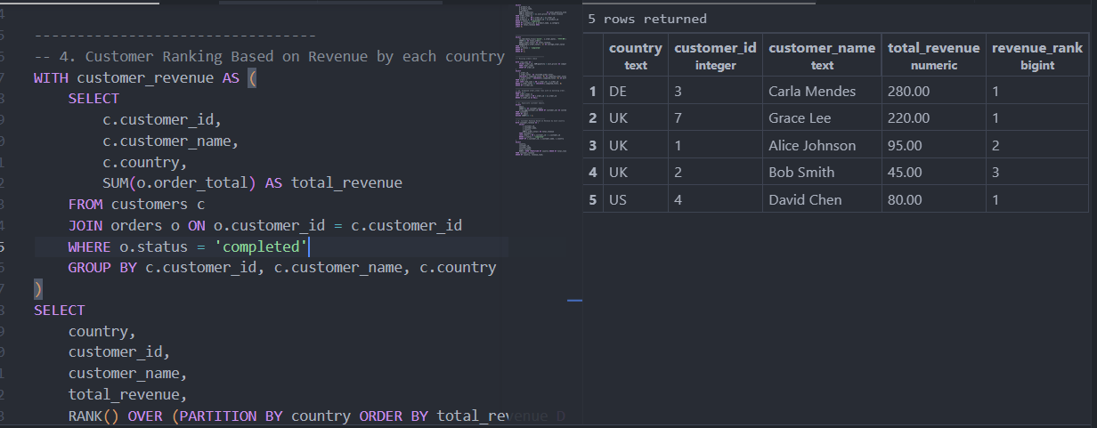

Question 5 — Order Fact View
order_fact — full 10-row output, including computed_order_total and order_total_diff for reconciliation.
